**1. Check if user configured**

**git config --global user.name**

2. If it returns your name, you’re set!

If it returns nothing or displays an error message, type

**git config --global user.name “Your Name”**

**3. Email**

**git config --global user.email**

If it returns your email address, you’re set!

If it returns nothing or displays an error message, type

**git config --global user.email your@email.com**

**4)Terminal**

1)Type **pwd** - this should show your home directory, the most basic of paths on your computer

2Type **cd** Documents - this will change your directory, and move you into your Documents folder

3)Type **mkdir** Flatiron - this will create a new folder, called Flatiron, to keep all of your Flatiron repositories and files

4)Type cd Flatiron - this will change your directory, moving you into the new Flatiron folder you just created

5)**creating Conda Virtual environment**(https://conda.io/projects/conda/en/latest/user-guide/tasks/manage-environments.html)::on git run:

**conda env create -f win_environment.yml** (can take upto 20 mins depending on internet connection)

#can also create env by

**conda create -n myen**

**conda activate myen~**

b)Activating the Conda Virtual Environment: To initiliaze a permanet shell which adds shell code to the startup scripts run:

**conda init bash**

Activate the environment run:

**conda activate learn-env**

c)To confirm that it worked, type the below: and confirm that the asterisk (*) is next to the learn-env environment.

**conda info --envs**

**6)Troubleshooting**

if you see a message that states “WARNING: A newer version of Conda exists”, run **conda update -n base conda** and then try again to create the environment.

If you see a message that states "file not found", double check that you are running this command from the directory that contains the .yml file. If you type ls you should see the environment.yml file. If you dont see it, you likely forgot to run cd dsc-data-science-env-config to change into the right directory.

**7)Setting your Default Environment**

1)Run below to create a new file.

**touch ~/.bash_profile**

2)Run below to add the configuration to your bash profile

**echo "conda activate learn-env" >> ~/.bash_profile**

3)Run below to activate the changes you just made

**source ~/.bash_profile**

If you are ever concerned about conflicting package versions, just remember that creating a new conda environment is as easy **as conda create --name new-env** - and it is very normal to have different environments with different packages for different purposes. Just remember that you've likely just set up learn-env to activate by default, so you'll need to either change that or activate other environments manually when needed.

8)If you don't see the learn-env option in those two places:

* Close the notebook in the browser
* Close down the notebook server from the terminal
  + (run ctrl + c and then type y to confirm that you want to close down jupyter)
* In the terminal, enter
* conda activate learn-env
* python -m ipykernel install --user --name learn-env --display-name "Python (learn-env)"

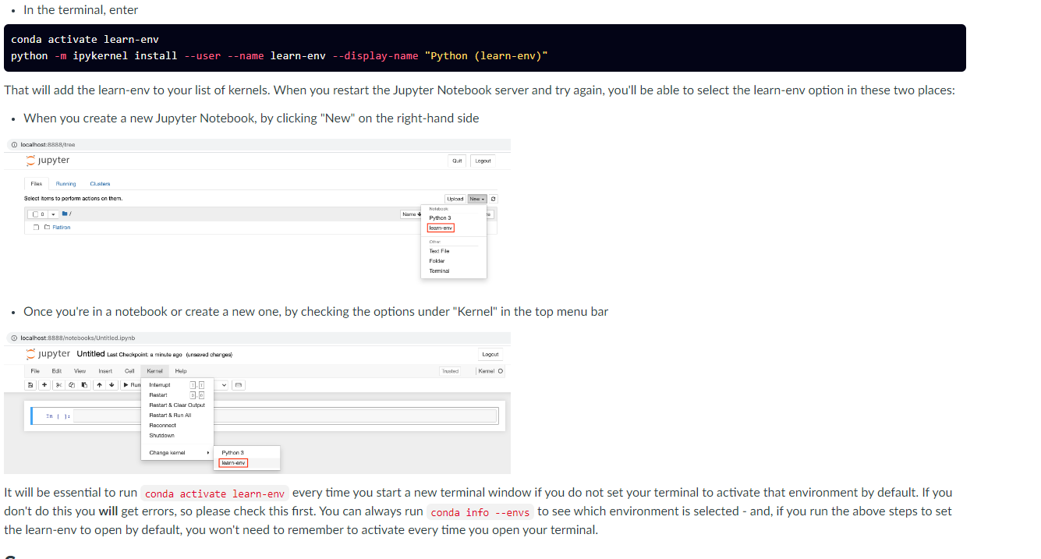

16 commands for terminal

**pwd**

**cd**- takes you to home folder

**cd** .. one folder up

ls - list all files

ls -a (list all files including hidden files)

ls -l gives a long listing of files (including file size and last edit times)

You can also pass multiple parameters simultaneously, such as **ls -al** to produce a detailed listing of all files.

you wanted to list all files in the current working directory that begin with a, you could type **ls a\***

list all pdf files in the current working directory you can use **ls *.pdf**, or to list all text files, you can use **ls *.txt**

mkdir command, which stands for make directory. Try it out with mkdir NewFolderName. Afterward, use the ls command to see that there is indeed a new folder, and if you wish, move into the new folder using the cd command.

**Want to open jupyter**

17**. ctrl + L** to highlight the url bar

18. Always activate the virtual environment

**conda activate learn-env**

**jupyter notebook**

19.Add new folder to github

git remote add origin the_url_for_the_repo